**The University of Azad Jammu and Kashmir**



**Name : Nida Hameed**

**Session : 2024-2028**

**Course Title: CA&LD**

**Submitted to : Engr . Sidra Rafique**

**De Morgan’s Law for NAND Gate:**

**Procedure**

I opened Electronics Workbench and started a new project.

1. I added the 7400 IC (NAND gate), 7404 IC (NOT gate), and 7432 IC (OR gate) to the workspace.
2. I connected Vcc (pin 14) and GND (pin 7) on all three ICs.
3. For the left side of the circuit, I used a single NAND gate from the 7400:
   * I connected two switches to the inputs (pins 1 and 2).
   * The output was taken from pin 3, which showed the direct NAND result of A and B.
4. For the right side, I built the equivalent circuit using De Morgan’s Law:
   * I took the same two inputs (A and B) and connected each to a NOT gate .
   * Their outputs were then connected to an OR gate .
   * This way I created: A' + B' which, according to De Morgan’s Law, is equal to (A ⋅ B)’.
5. I connected LEDs to both outputs (NAND and OR-NOT combo) to compare them.
6. I tested all input combinations using the two switches:
   * (0,0), (0,1), (1,0), (1,1)

which is De Morgan’s Theorem.

1. The LEDs lit up the same on both sides every time, so the proof worked perfectly.
2. This was a clean and clear way to verify De Morgan's Law using logic gates and ICs.

Formula:

(A.B)’=A’+B’

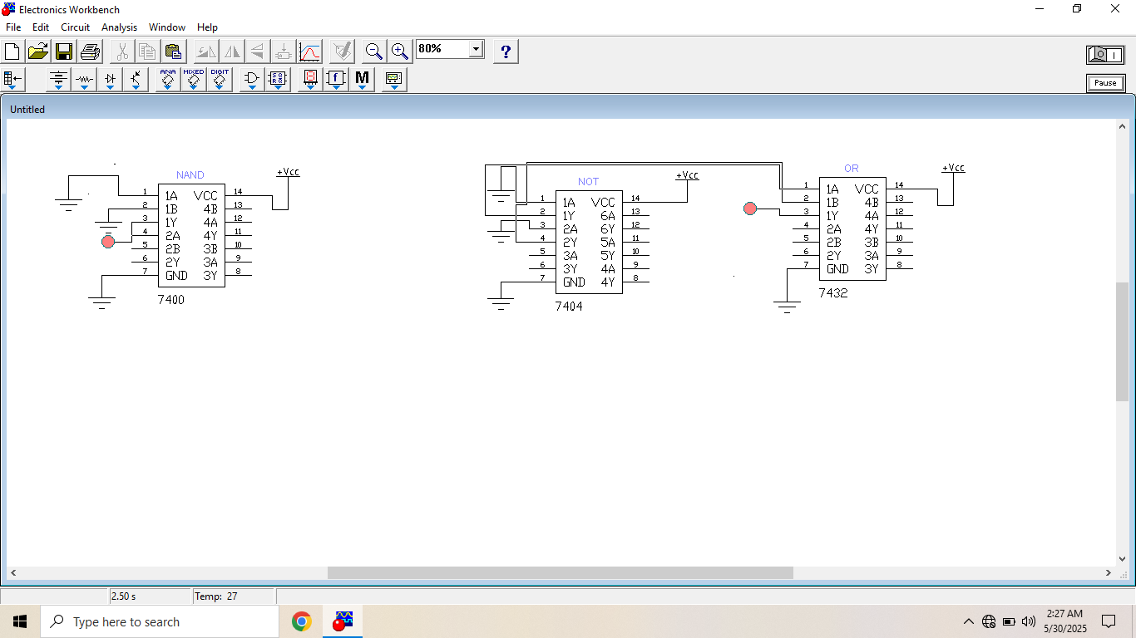

**Hardware circuit**

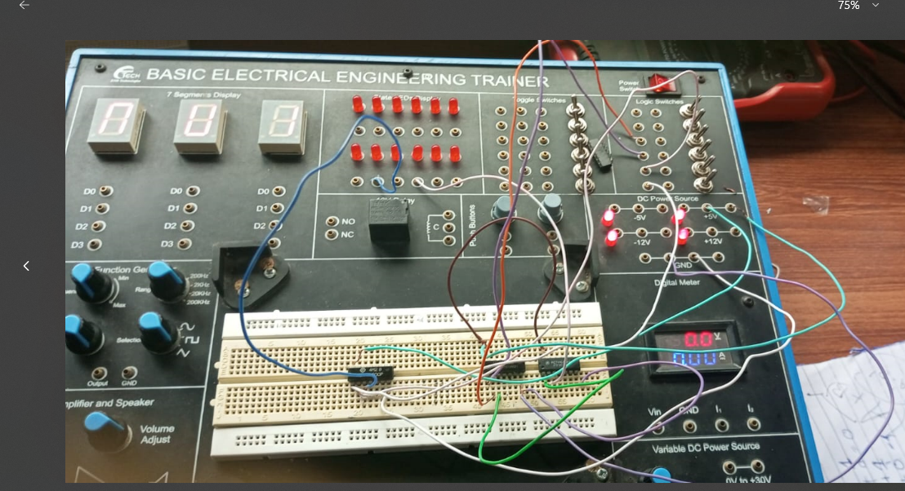

**Table:**

|  |  |  |  |  |  |  |
| --- | --- | --- | --- | --- | --- | --- |
| A | B | A’ | B’ | A.B | (A.B)’ | A’+B’ |
| 1 | 1 | 0 | 0 | 1 | 0 | 0 |
| 1 | 0 | 0 | 1 | 0 | 1 | 1 |
| 0 | 1 | 1 | 0 | 0 | 1 | 1 |
| 0 | 0 | 1 | 1 | 0 | 1 | 1 |

**De Morgan’s law for NOR Gate:**

**Procedure**

I opened Electronics Workbench and started a new project.

1. I added the 7402 IC (NOR gate), 7408 IC (AND gate), and 7404 IC (NOT gate) to the workspace.
2. I connected Vcc (pin 14) and GND (pin 7) on all three ICs.
3. On the left side of the circuit, I used a single NOR gate :
   * I connected two switches as inputs to pins 1 and 2 of the IC.
   * The output from pin 3 gave me NOR(A, B) directly.
4. On the right side, I built the De Morgan equivalent using NOT and AND gates:
   * I passed the same two inputs through two NOT gates from the 7404.
   * Then I connected those inverted outputs to an AND gate from the 7408.
   * This built: A' ⋅ B' which is the same as (A + B)’ by De Morgan’s Law.
5. I connected LEDs to both outputs to visually compare the NOR and the AND-NOT combination.
6. I tested all input combinations using the switches:
   * (0,0), (0,1), (1,0), (1,1)
7. For every test, both outputs matched showing the same logic level on both LEDs.
8. The circuit worked exactly how it should both sides gave the same output for all input cases.

**Formula:**

(A+B)’=A’.B’

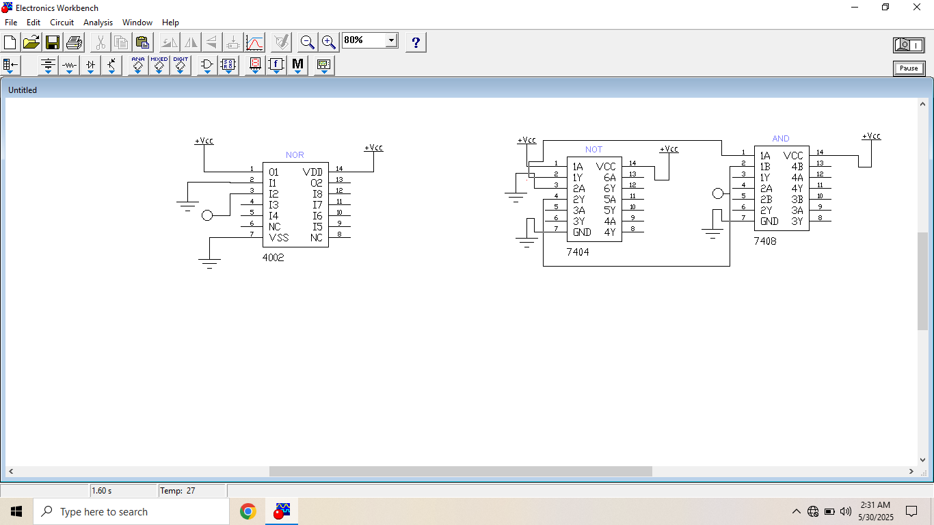

**Table:**

|  |  |  |  |  |  |  |
| --- | --- | --- | --- | --- | --- | --- |
| A | B | A’ | B’ | A+B | (A+B)’ | A’.B’ |
| 1 | 1 | 0 | 0 | 1 | 0 | 0 |
| 1 | 0 | 0 | 1 | 1 | 0 | 0 |
| 0 | 1 | 1 | 0 | 1 | 0 | 0 |
| 0 | 0 | 1 | 1 | 0 | 1 | 1 |